|  |
| --- |
| Department of Software Engineering  Mehran University of Engineering and Technology, Jamshoro |

|  |  |  |  |
| --- | --- | --- | --- |
| Course: SW222 – Database Management & Administration | | | |
| Instructor | Ms Shafiya | **Practical/Lab No.** |  |
| Date | 24.02.2021 | **CLOs** | 2 |
| Signature |  | **Assessment Score** | 2 Marks |

|  |  |
| --- | --- |
| Topic | To become familiar with Table creation and population of table |
| Objectives | * To become familiar with Table Creation * To become familiar with Rows Insertion |

|  |
| --- |
| Lab Discussion: Theoretical concepts and Procedural steps |

**Data Definition Language (DDL)**

Data Definition Language (DDL) is a standard for commands that define the different structures in a database. DDL statements create, modify, and remove database objects such as tables, indexes, and users. Common DDL statements are CREATE, ALTER, and DROP.

**CREATE :** Use to create objects like CREATE TABLE, CREATE FUNCTION,

                        CREATE SYNONYM, CREATE VIEW. Etc.

**Syntax:**

CREATE TABLE "name_of_table"

("column_1" "data_type",

"column_2" "data_type",

"column_3" "data_type",

... )

**Syntax With Primary Key:**

CREATE TABLE "name_of_table"

("column_1" "data_type",

"column_2" "data_type",

"column_3" "data_type",

CONSTRAINT constraint_name PRIMARY KEY (column_1, column_2)

... )

**Example:**

CREATE TABLE PERSON

(

NUM NUMBER NOT NULL ,

FIRSTNAME VARCHAR2(20) NULL ,

GENDER_CODE CHAR(1) NULL ,

BIRTH_DTTM DATE NULL ,

INACTIVE_DATE DATE NULL ,

LASTNAME VARCHAR2(30) NULL ,

CONSTRAINT PK_PERSON PRIMARY KEY (NUM)

)

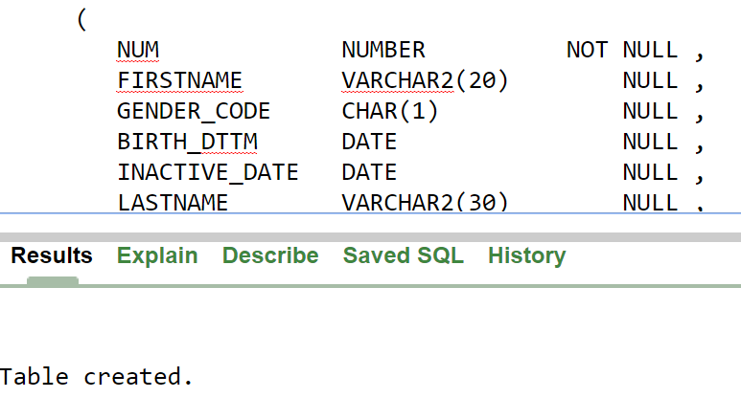

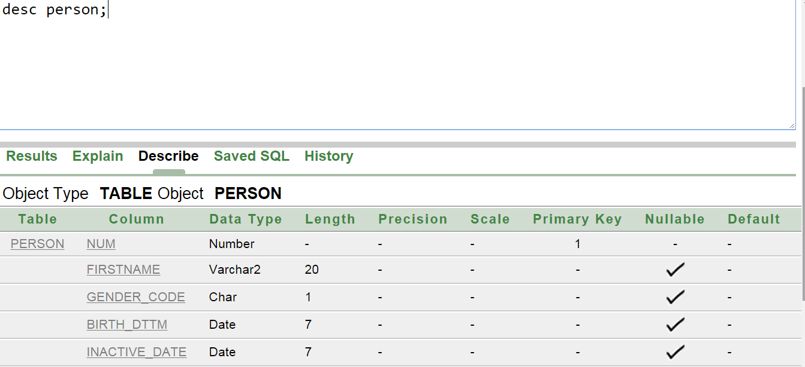

**Alter:**

The Oracle **ALTER TABLE statement** is used to add, modify, or drop/delete columns in a table. The Oracle ALTER TABLE statement is also used to rename a table.

**ADD COLUMN IN TABLE**

**Syntax**

To **ADD A COLUMN** in a table, the Oracle ALTER TABLE syntax is:

ALTER TABLE table_name

ADD column_name column-definition;

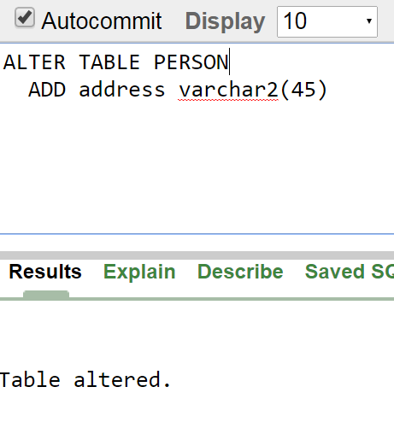

## MODIFY COLUMN IN TABLE

### Syntax

To **MODIFY A COLUMN** in an existing table, the Oracle ALTER TABLE syntax is:

ALTER TABLE table_name

MODIFY column_name column_type;

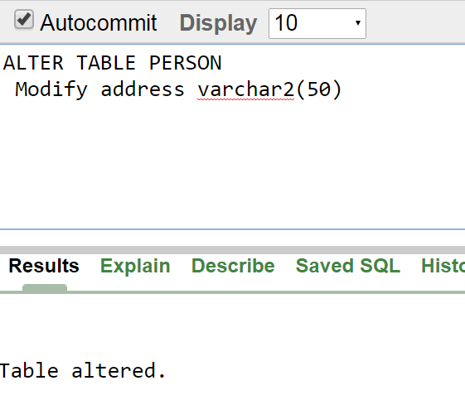

## DROP COLUMN IN TABLE

### Syntax

To **DROP A COLUMN** in an existing table, the Oracle ALTER TABLE syntax is:

ALTER TABLE table_name

DROP COLUMN column_name;

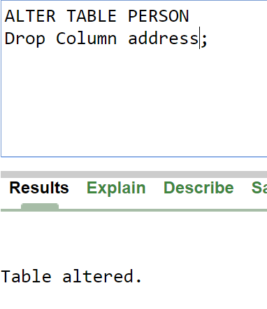

## RENAME COLUMN IN TABLE

To **RENAME A COLUMN** in an existing table, the Oracle ALTER TABLE syntax is:

ALTER TABLE table_name

RENAME COLUMN old_name to new_name;

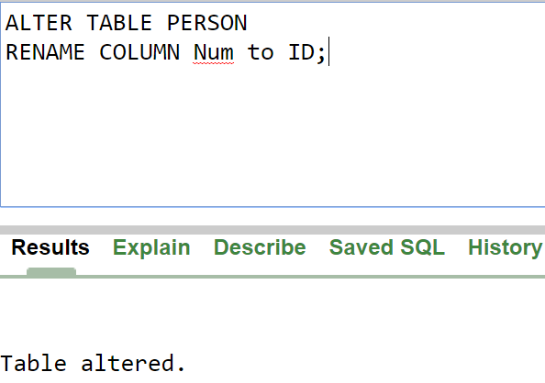

## RENAME TABLE

### Syntax

To **RENAME A TABLE**, the Oracle ALTER TABLE syntax is:

ALTER TABLE table_name

RENAME TO new_table_name;

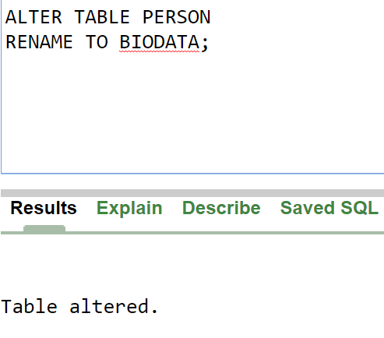

**TRUNCATE:** Use to truncate (delete all rows) a table.

### Syntax

TRUNCATE TABLE table_name

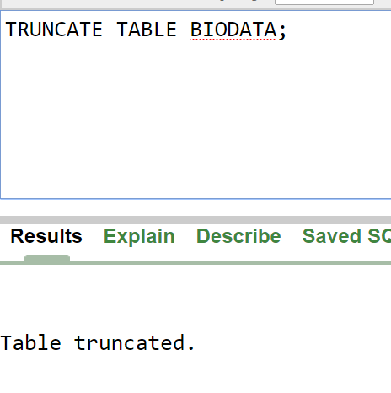

**DROP:** The SQL **DROP TABLE** statement is used to remove a table definition and all data, indexes, triggers, constraints, and permission specifications for that table.

### Syntax

DROP TABLE table_name

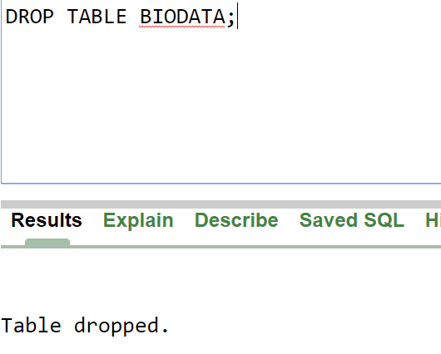

**Data Manipulation Language (DML) Statements**

Data manipulation language (DML) statements access and **manipulate data** in existing schema objects. These statements do not implicitly **commit** the current transaction. The data manipulation language statements are:

* **INSERT - insert data into a table**

**Syntax:**

The below syntax can be followed if the values for all the columns in the table is definite and known.

INSERT INTO table

VALUES (column1 value, column2 value,

...);

The below syntax can be used if only few columns from the table have to be populated with a value. Rest of the columns can deduce their values either as NULL or from a different business logic.

INSERT INTO table (column1 name, column2 name, . . .)

VALUES (column1 value, column2 value, . . .);

|  |
| --- |
| Lab Tasks |

1. Create a table named BOOKS that will have 4 columns as:
   1. Book_ID with NUMBER data type. (Also PK)
   2. Book_Name with varchar data type and length 30.
   3. Author_Name with varchar data type and length 20.
   4. Book_Isbn with varchar data type and length 30.
2. Modify the table created in the previous step by adding two new columns (related to the category of books) of your choice.
3. Insert 5 rows of records in the table created in question number 1. Display the data.
4. Modify the table created in question 1 by deleting one of the newly created columns.
5. Truncate the table BOOKS. Display the output. Finally drop the table.